Task Screenshots

1. Post request for PHP webhook.

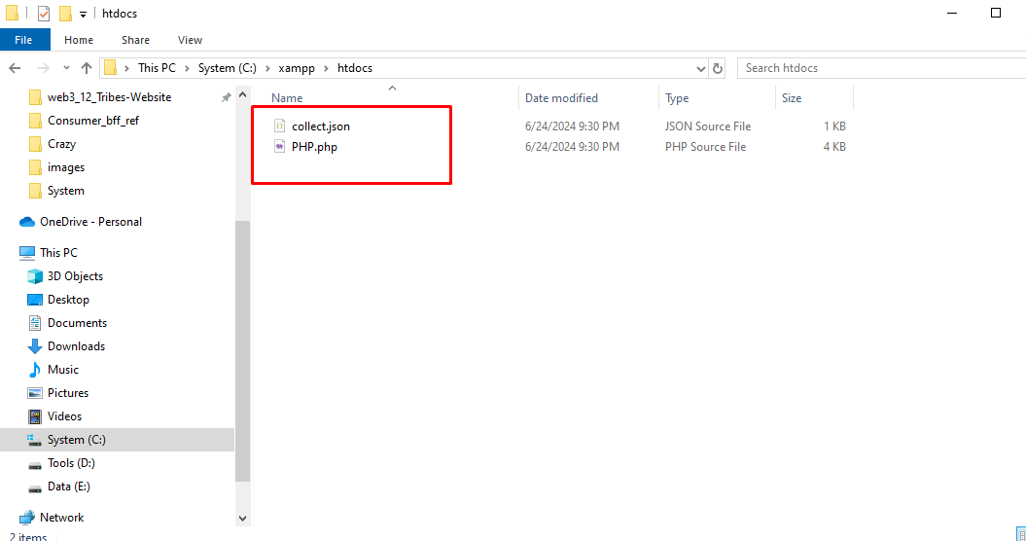

Figure 1. Directory structure of PHP task(including result collect.json)

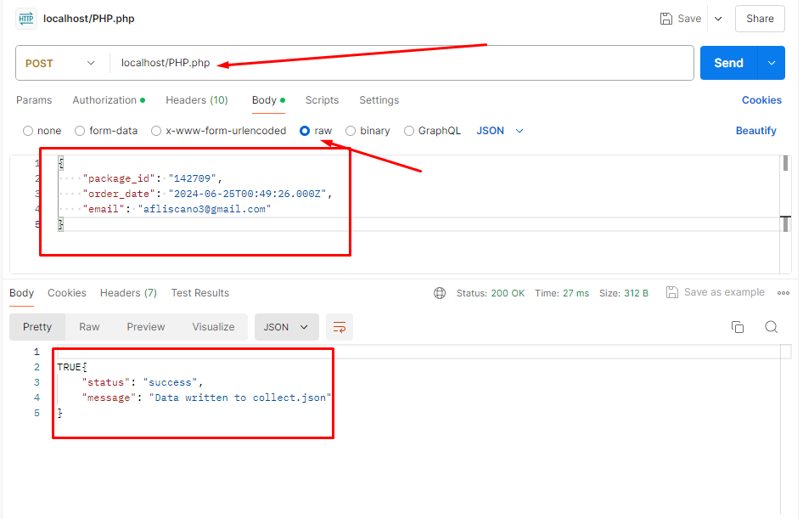

Figure 2. request and response for PHP task.